CSC3170 Project

**1.Project Description:**

Constructing a database for a food recipe website. The website supports two roles: author of recipes (author) and writer of recipe reviews (reviewer). Authors can create and upload their own made recipes and check their history of uploaded recipes. Reviewers can search recipes in the database based on recipe categories and write reviews and ratings for recipes.

Populate the Database with Realistic Data from:

<https://www.kaggle.com/datasets/irkaal/foodcom-recipes-and-reviews/data>

**2. Requirement Analysis:**

Roles:

1. Review Writer

2. Recipe Author

Entities:

Authors, Reviewers, Recipes, Ingredients, Nutrients, Categories, Reviews & Ratings

Relationships:

Authors can create multiple Recipes.

Each Recipe can have multiple components of Ingredients.

Each Recipe can have multiple components of Nutrients.

Recipes can belong to multiple Categories.

Reviewers can leave multiple Reviews & Ratings for Recipes.

**3. The database and SQL design:**

**Schema Design:**

Populate the Database with Realistic Data: (sample 5 rows)

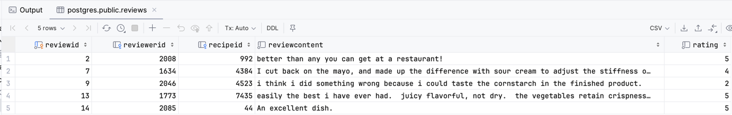

**4. Front and back-end design and implementation:**

|  |  |  |
| --- | --- | --- |
| Requirements | The function that implements it | Function Introduction |
| Author/Reviewer Login | main | Read user input data (1. login) |
| user_login (Front-end + Back-end) | Read user input data (login in as author or reviewer, Id, and password), hash and crypt password, encapsulate and pass to backend.  Check whether user id in the database or not.  If user id is not correct, ask user to enter id again.  If user id is correct, redirect user to next step. |
| check_password (Back-end) | Accepting packets sent from the front-end, unpacking and analyzing the operations to be implemented, check whether password is correct or not.  If password is not correct, ask user to enter id and password again.  If password is correct, redirect user to next step. |
| Author/Reviewer Register | main | Read user input data (2. Register) |
| user_register (Front-end+Back-end) | Read user input data (Register as author or reviewer, Id, Name, and password)  Check whether user id is 10 digits or not.  Check whether user password is 6 digits or not.  If not correct, ask user to enter information again.  If correct, go to next step—check whether user id is unique or not.  If user id already exists in the database, ask user to enter again.  If user id does not exist in the database, hash user password and insert information into the table. |
| is_id_unique (Back-end) | Check whether id that user entered exists in the database or not. |
| Author checks self-uploaded recipes | author_post_login | Read user input data (user need to choose 1. View your uploaded recipes) |
| view_author_recipes | Return recipe id and recipe name based on author id |
| Author creates a recipe | author_post_login | Read user input data (user need to choose 2. Upload a new recipe) |
| create_new_recipe | Read user input data: user entered Recipe Name, Description, Instructions, Ingredient parts, Ingredient quantities, nutrients (including calories, fat, sugar...).  Generate recipe id, then insert all information into different tables. |
| Author checks recipe details | check_recipe_details | Read user input data (user can input 1-6, and recipe id) |
| check_instruction_description | If user input 1, select information from recipe table.  return recipe instruction and description based on recipe id that user entered. |
| check_ingredient | If user input 2, join recipe table and ingredient table.  return recipe ingredient parts and ingredient quantities based on recipe id that user entered. |
| check_nutrient | If user input 3, join recipe table and nutrient table.  return recipe nutrient based on recipe id that user entered |
| check_category | If user input 4, join recipe table and category table.  return category that the recipe belongs to base on recipe id that user entered |
| Author/Reviewer checks all reviews of a recipe | check_recipe_details | Read user input data: recipe id |
| check_all_reviews | Join recipe table and reviews table.  Return review contents, recipe id, and recipe name based on recipe id that user gives. |
| Author/Reviewer checks average rating of a recipe | check_recipe_details | Read user input data: recipe id |
| check_average_rating | Join recipe table and review table. Calculate average rating based on all ratings that a recipe has.  Return average rating, recipe id, and recipe name. |
| Reviewer checks self-reviewed recipes | reviewer_post_login | Read user input data: 1. View recipes I have reviewed |
| view_reviewed_recipes_by_reviewer | Join reviewer table, reviews table, and recipes table.  Return recipe id, recipe name, rating, reviews based on reviewer id that user gives. |
| System recommends recipes based on reviewer’s choice of category | reviewer_post_login | Read user input data: 2. View new recipes by category |
| view_recipes_by_category | Join category table and recipe table.  Return recipe id, recipe name based on category name that user gives. |
| Reviewer checks recipe details | view_recipes_by_category | Read user input data: category name.  Return recipe id, recipe name based on category name. |
| check_recipe_details | Enter recipe id, then similar procedure as Author check recipe details |
| Reviewer writes reviews and ratings for a recipe | reviewer_post_login | Read user input data: 3. Write review for a recipe |
| create_new_review | Read user input data: recipe id, review content, rating.  Generate a new review id, then insert all information into reviews table. |
| Exit | main | Read user input data: Exit  Kill the program. |

**5. How to use the system:**

Welcome interface

**文本

**

Choose to register

Choose to register as an author (register as a reviewer is similar, not show here)

Input needs to follow the requirement, or you will be redirect to re-enter

Log in as author and check self-uploaded recipes

Check recipe details, here we choose to see description and instructions (other details are similar)

Upload new recipe as an author

Log in as a reviewer and view self-uploaded reviews

View recipe details as a reviewer, here we view ingredient as an example.

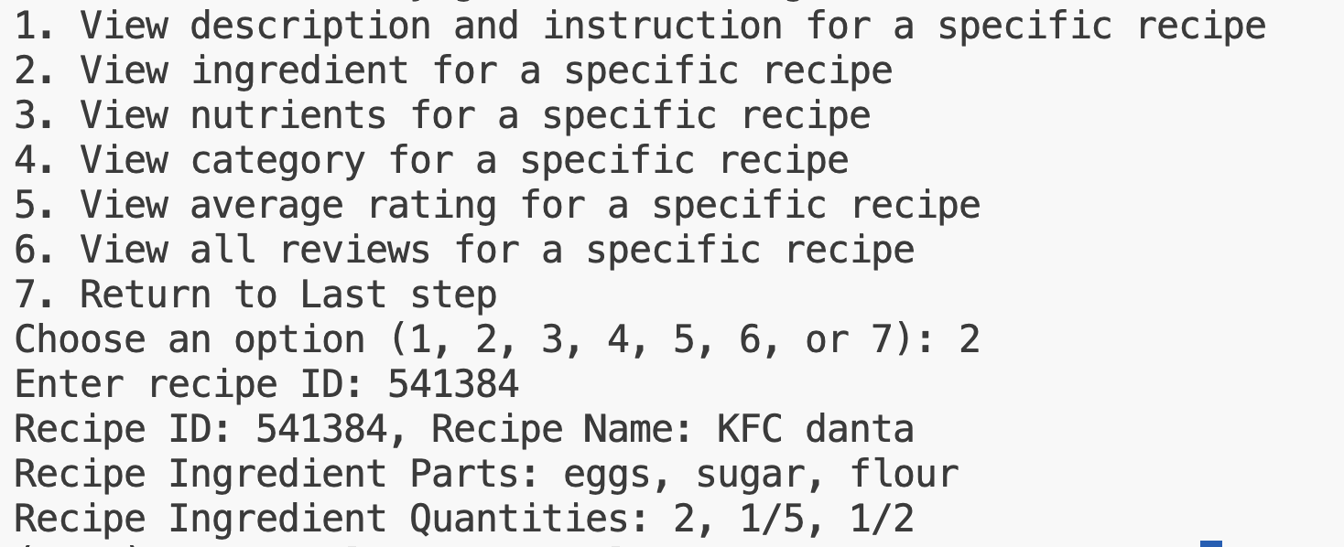

Reviewer asks the system to recommend a recipe based on category name that user entered. Here we enter “Chicken” as an example.

View details of a recipe is like previous steps.

Here we write a review for this recipe:

